31.15: a)

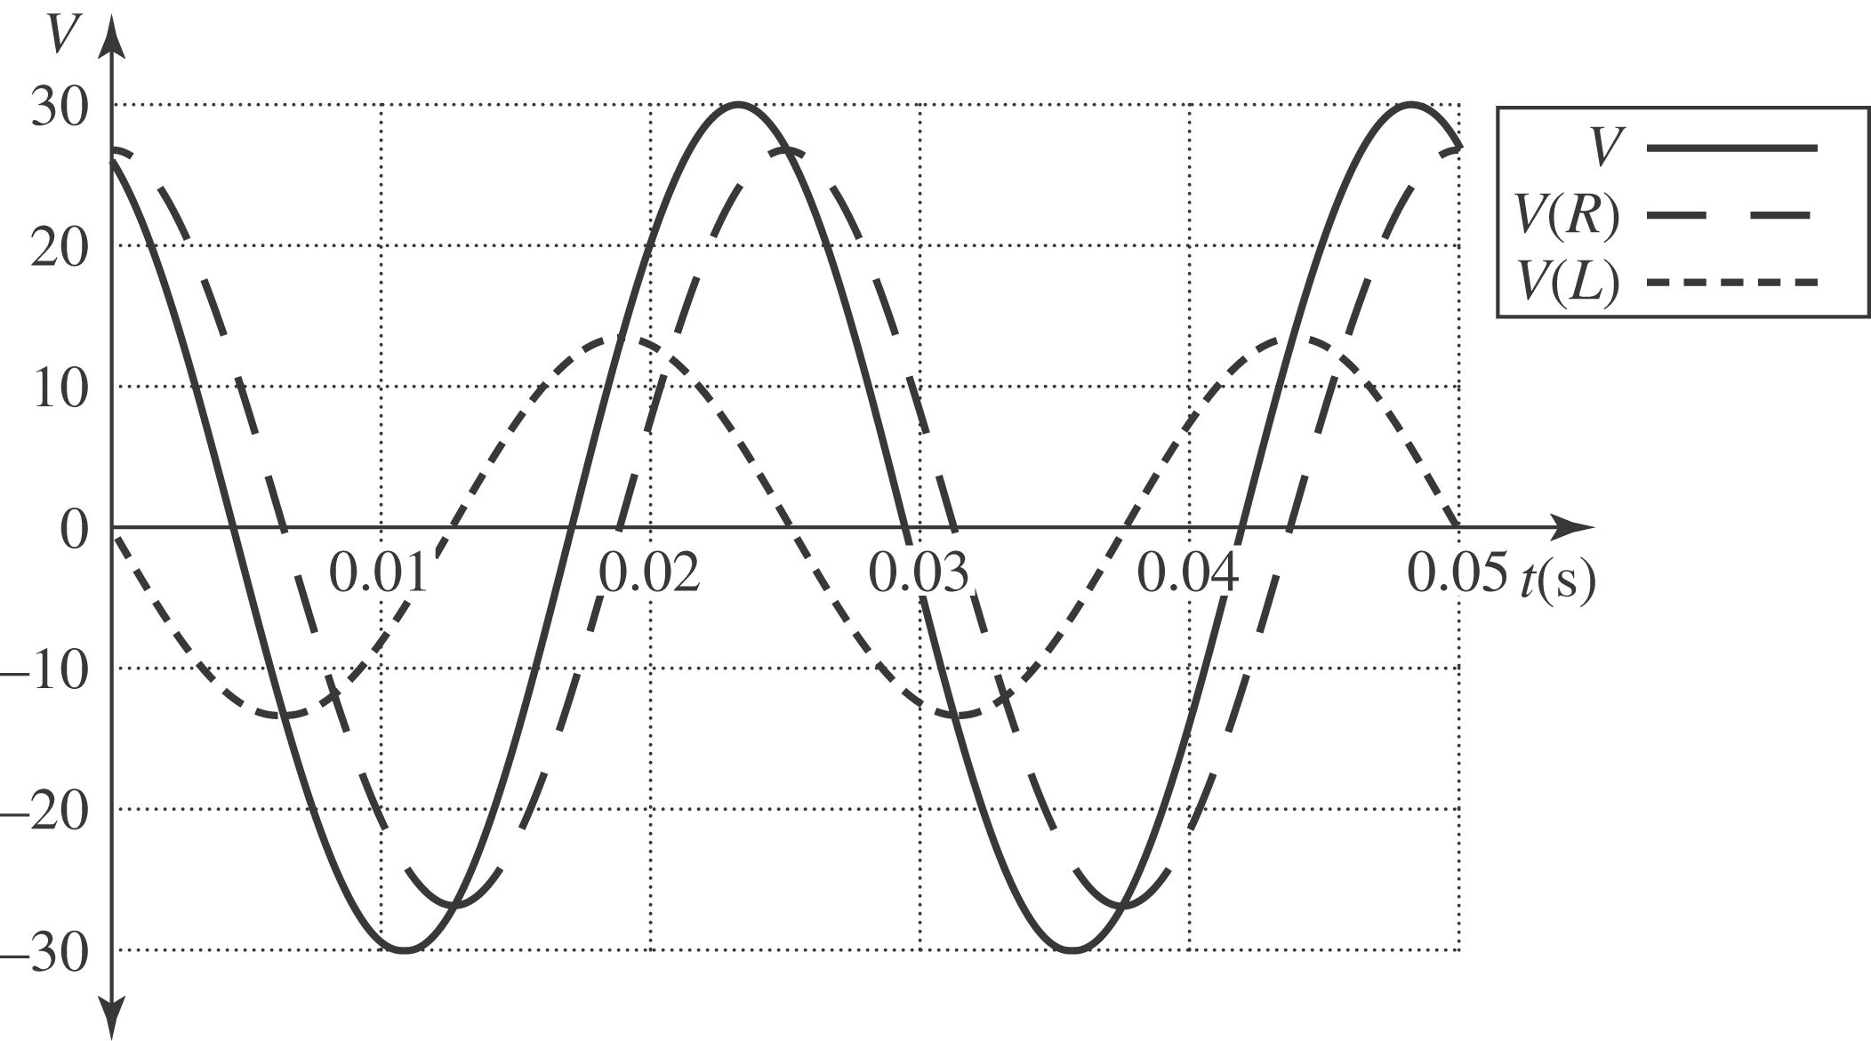

b) The different voltages are:
c) Be careful with radians vs. degrees in above expressions!

